ASSIGNMENT NO. 11: Indexing and Query Optimization Queries

Student Name | Anushka Pachpute | Roll Number | 20971
Batch | SY. BSc Data Science | Topic | WB(Assignment-11)

Q1) Create a MySQL database named SalesDB and a table named OrderData. OrderData Table
Column Name | Data Type | Constraint
OrderID | INT | PRIMARY KEY
CustomerName | VARCHAR(50) | NOT NULL
Email | VARCHAR(80) | NOT NULL
City | VARCHAR(30) | NOT NULL
ProductCategory | VARCHAR(30) | NOT NULL
OrderDate | DATE | NOT NULL
OrderAmount | DECIMAL(10,2) | NOT NULL
OrderStatus | VARCHAR(20) | NOT NULL

Insert at least 12 records into the table.

QUERY:

CREATE TABLE OrderData (
OrderID INT PRIMARY KEY,
CustomerName VARCHAR(50) NOT NULL,
Email VARCHAR(80) NOT NULL,
City VARCHAR(30) NOT NULL,
ProductCategory VARCHAR(30) NOT NULL,
OrderDate DATE NOT NULL,
OrderAmount DECIMAL(10,2) NOT NULL,
OrderStatus VARCHAR(20) NOT NULL
);
INSERT INTO OrderData
(OrderID, CustomerName, Email, City, ProductCategory, OrderDate, OrderAmount, OrderStatus)
VALUES
(1, 'Rahul Sharma', 'rahul@gmail.com', 'Mumbai', 'Electronics', '2026-01-05', 55000.00,
'Delivered'),
(2, 'Priya Patil', 'priya@gmail.com', 'Pune', 'Furniture', '2026-01-08', 32000.00, 'Delivered'),
(3, 'Aman Verma', 'aman@gmail.com', 'Nashik', 'Clothing', '2026-01-12', 8500.00, 'Pending'),
(4, 'Sneha Joshi', 'sneha@gmail.com', 'Mumbai', 'Electronics', '2026-01-20', 72000.00, 'Delivered'),
(5, 'Karan Mehta', 'karan@gmail.com', 'Thane', 'Furniture', '2026-02-03', 28000.00, 'Cancelled'),
(6, 'Neha Shah', 'neha@gmail.com', 'Pune', 'Electronics', '2026-02-08', 48000.00, 'Delivered'),
(7, 'Rohan Desai', 'rohan@gmail.com', 'Mumbai', 'Clothing', '2026-02-15', 12000.00, 'Pending'),
(8, 'Meera Kulkarni', 'meera@gmail.com', 'Nashik', 'Furniture', '2026-02-22', 36000.00,
'Delivered'),
(9, 'Arjun Nair', 'arjun@gmail.com', 'Thane', 'Electronics', '2026-03-02', 64000.00, 'Shipped'),
(10, 'Divya More', 'divya@gmail.com', 'Mumbai', 'Furniture', '2026-03-07', 41000.00, 'Delivered'),
(11, 'Isha Singh', 'isha@gmail.com', 'Pune', 'Clothing', '2026-03-12', 15000.00, 'Shipped'),
(12, 'Om Jadhav', 'om@gmail.com', 'Mumbai', 'Electronics', '2026-03-18', 59000.00, 'Pending');

OUTPUT:
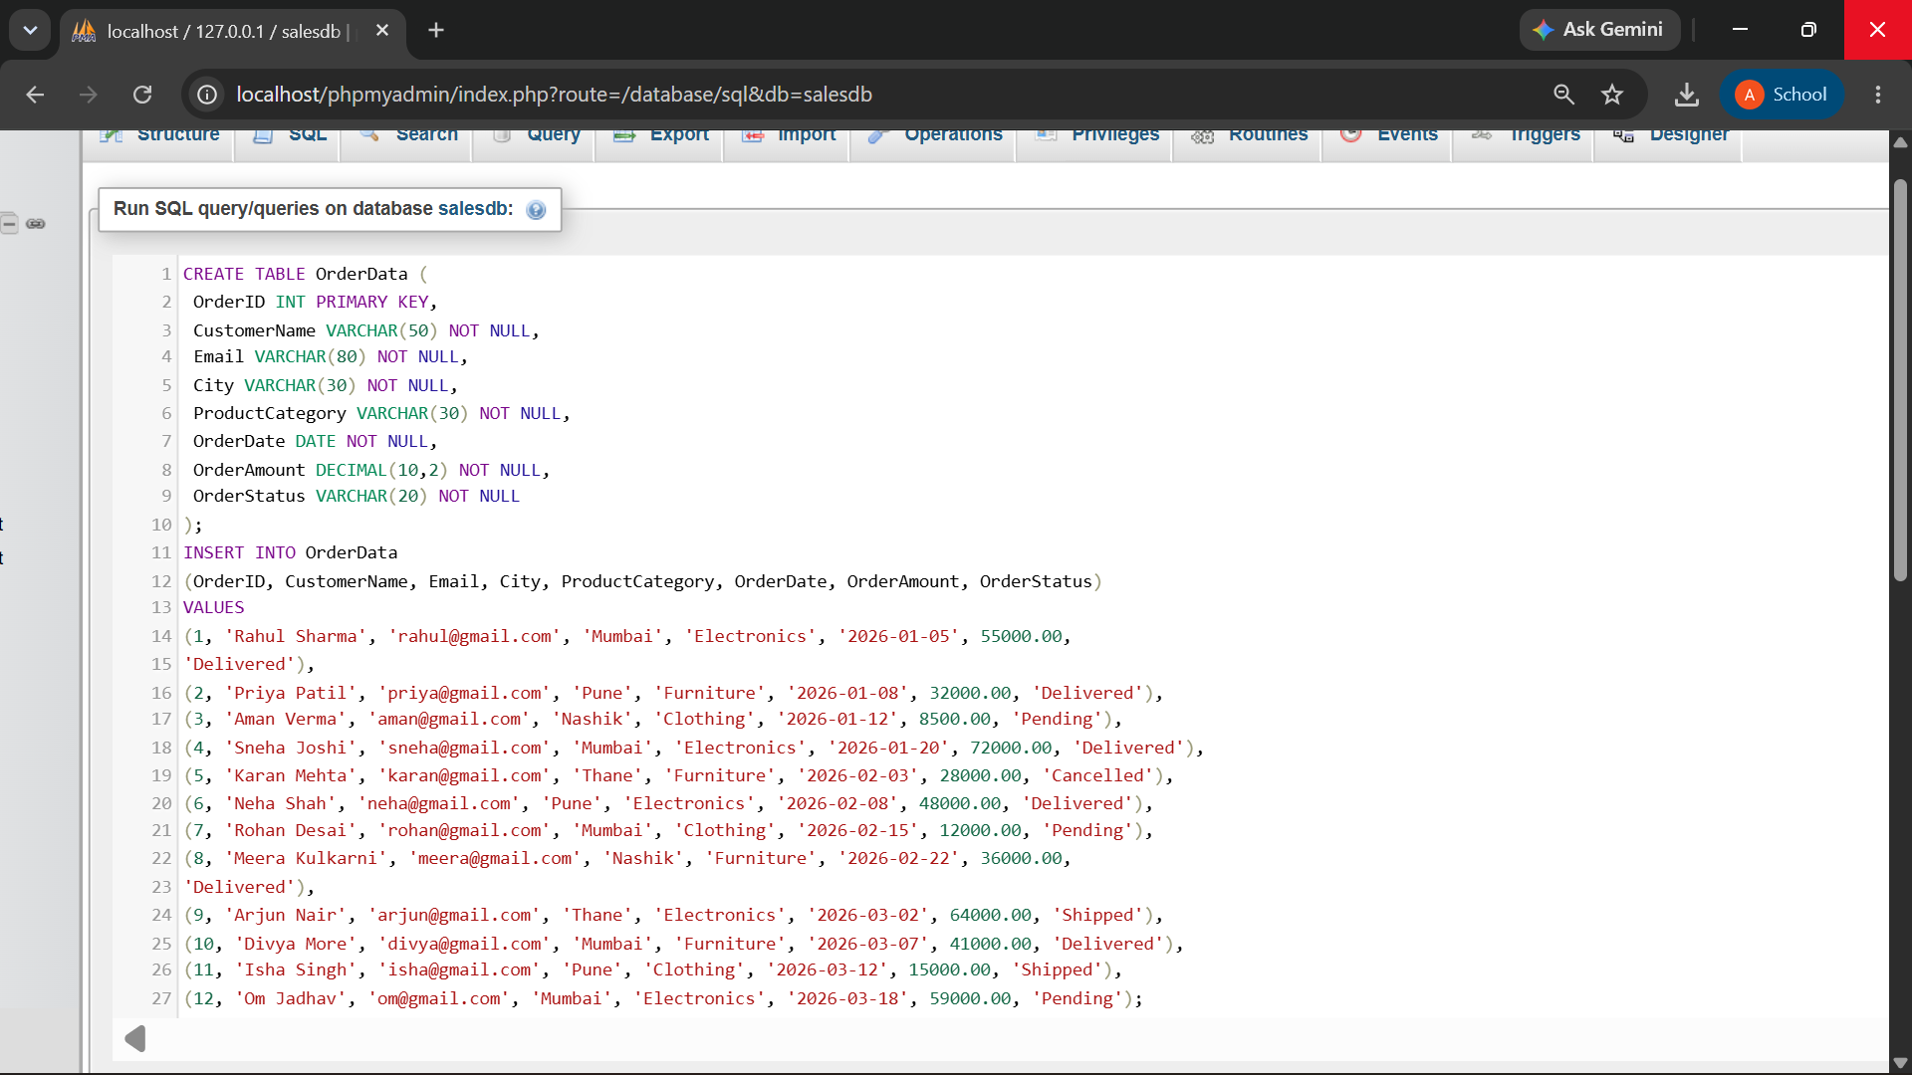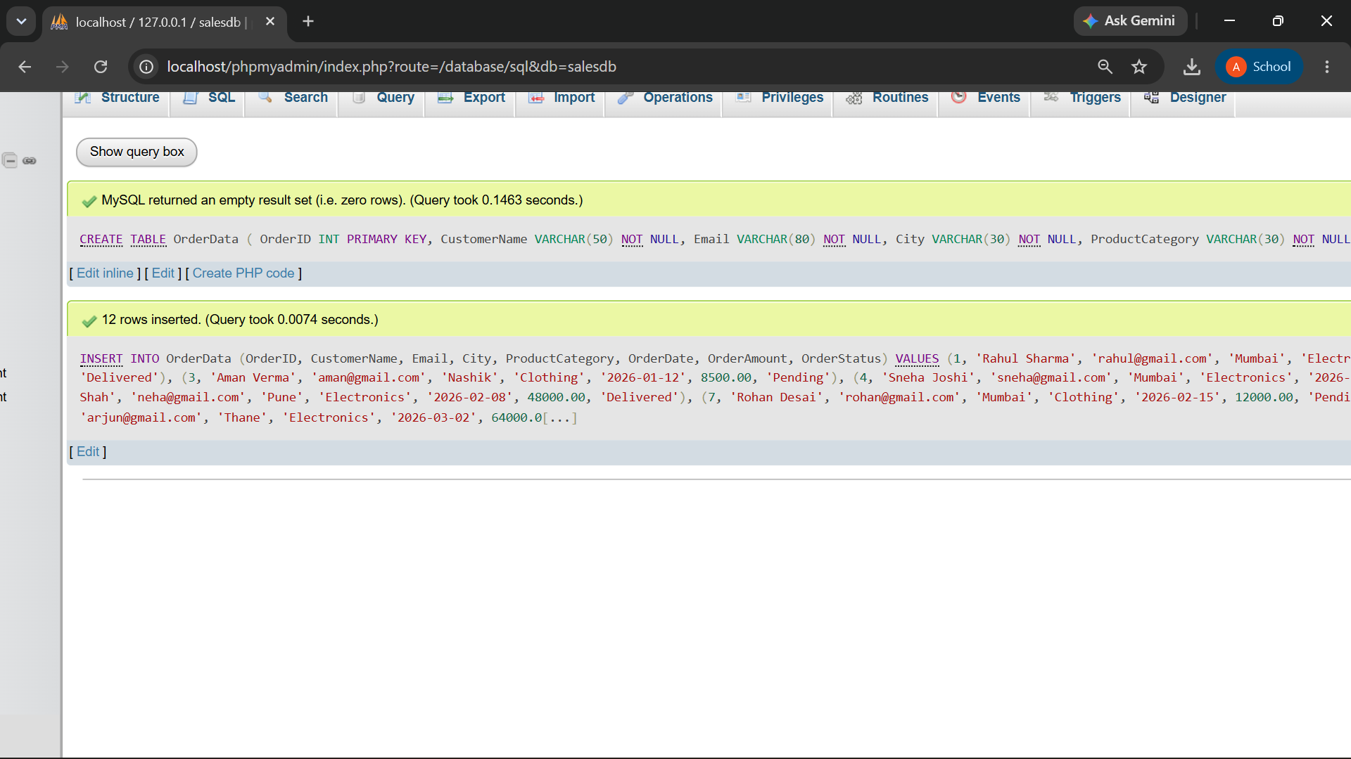

Q2) Create the following MySQL indexes on the OrderData table:
Index Name | Column | Index Type
idx_city | City | Normal index
idx_email | Email | Unique index
idx_order_date | OrderDate | Normal index

Display all indexes using SHOW INDEX.

QUERY:

CREATE INDEX idx_city
ON OrderData(City);

CREATE UNIQUE INDEX idx_email
ON OrderData(Email);

CREATE INDEX idx_order_date
ON OrderData(OrderDate);

SHOW INDEX FROM OrderData;

OUTPUT:

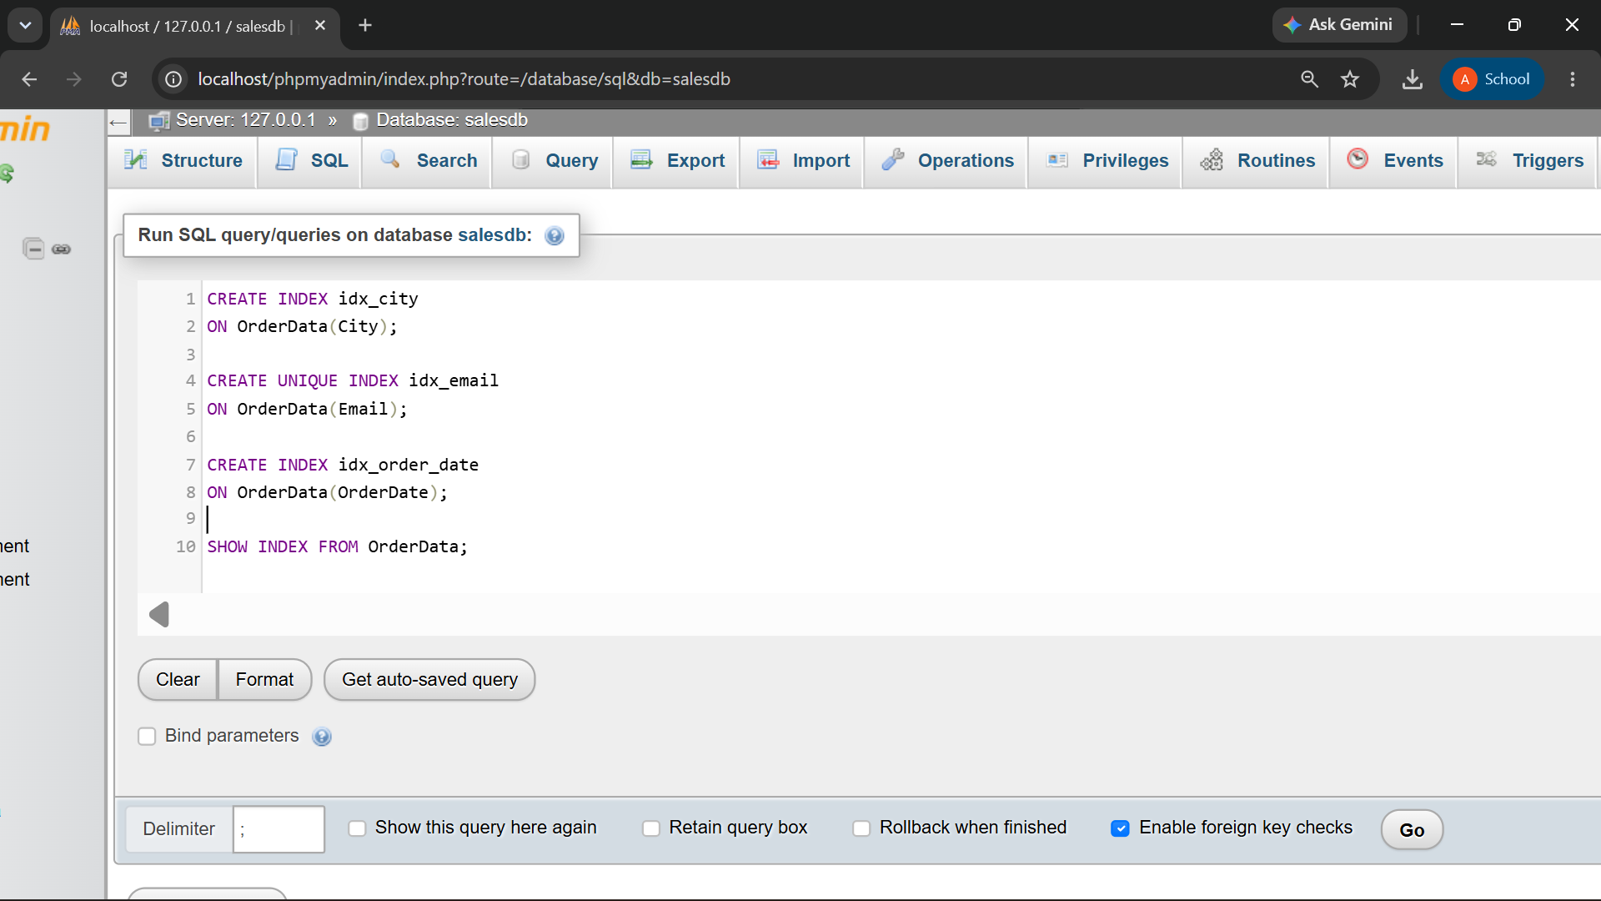

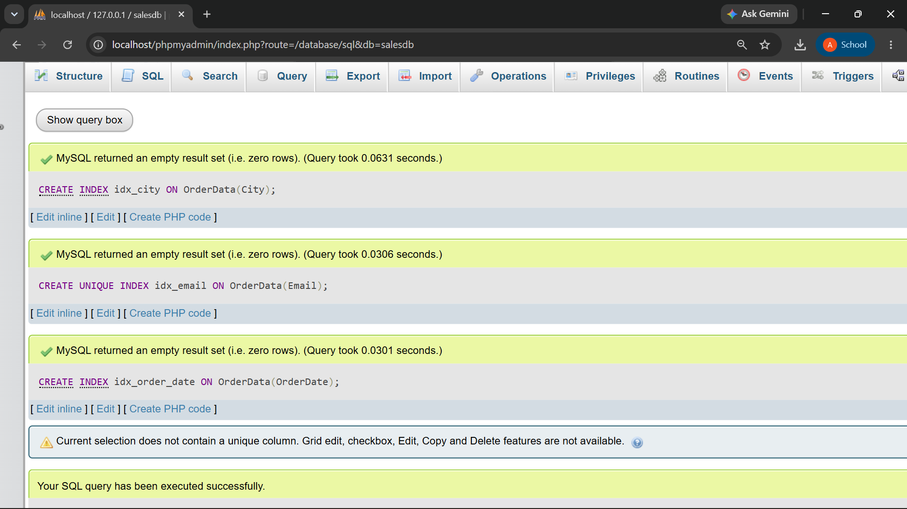
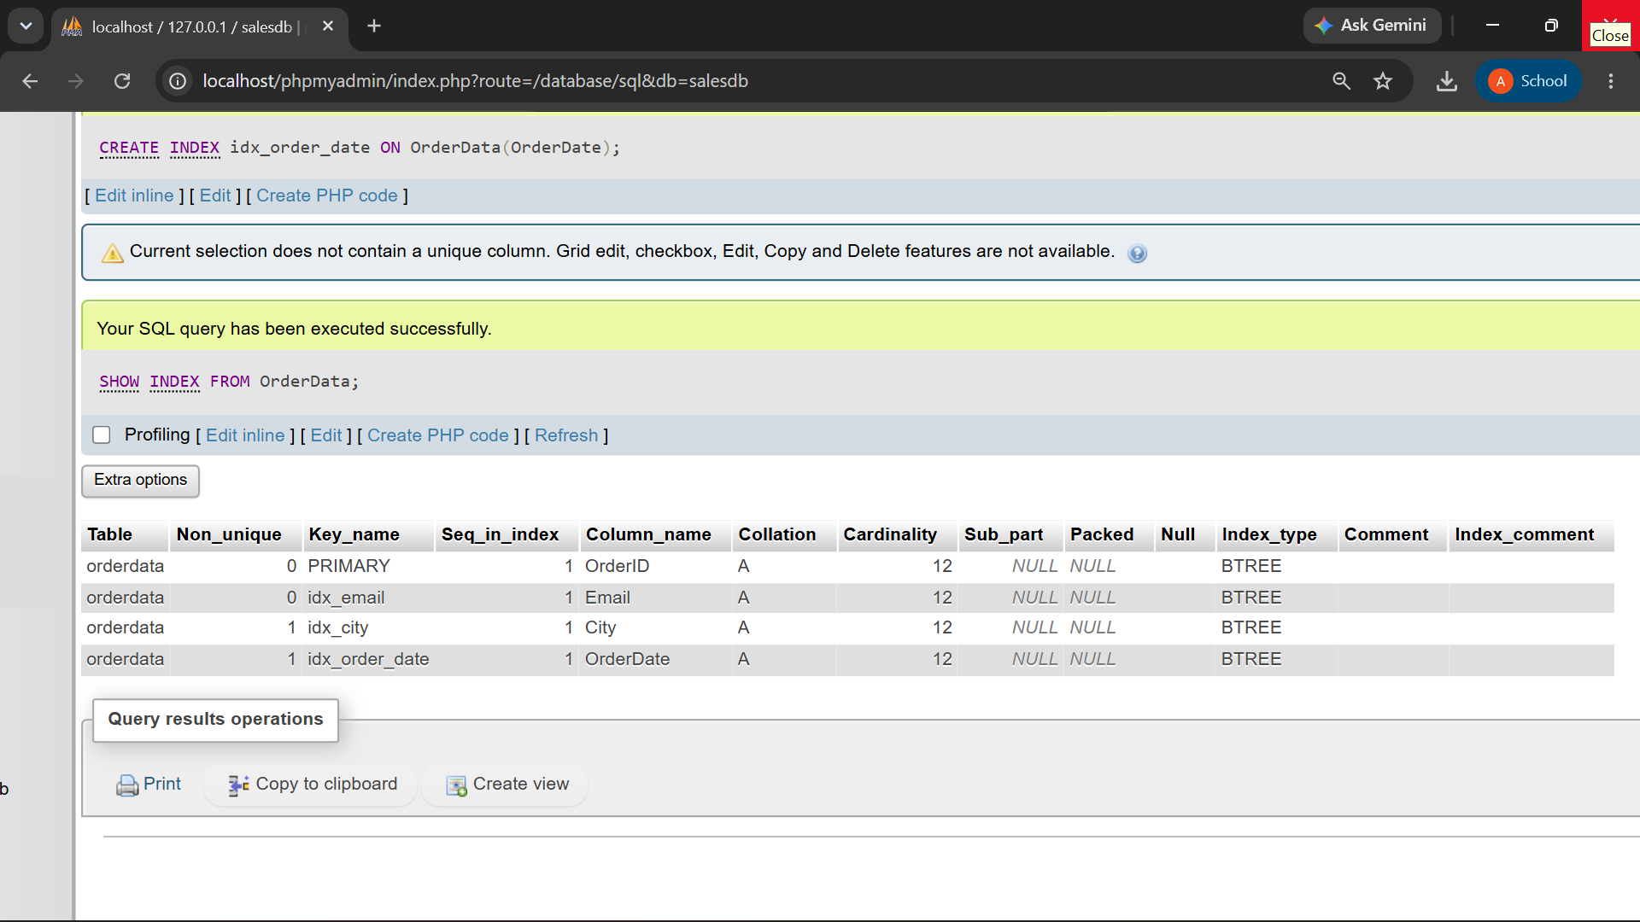

Q3) Create a composite index named idx_city_order_date.
The index should contain:
Index Position | Column
1 | City
2 | OrderDate
Write a query that searches for Mumbai orders within a specified date range.

QUERY:

CREATE INDEX idx_city_order_date
ON OrderData(City, OrderDate);

SELECT OrderID, CustomerName, City, OrderDate, OrderAmount
FROM OrderData
WHERE City = 'Mumbai'
AND OrderDate BETWEEN '2026-01-01' AND '2026-03-31';

OUTPUT:
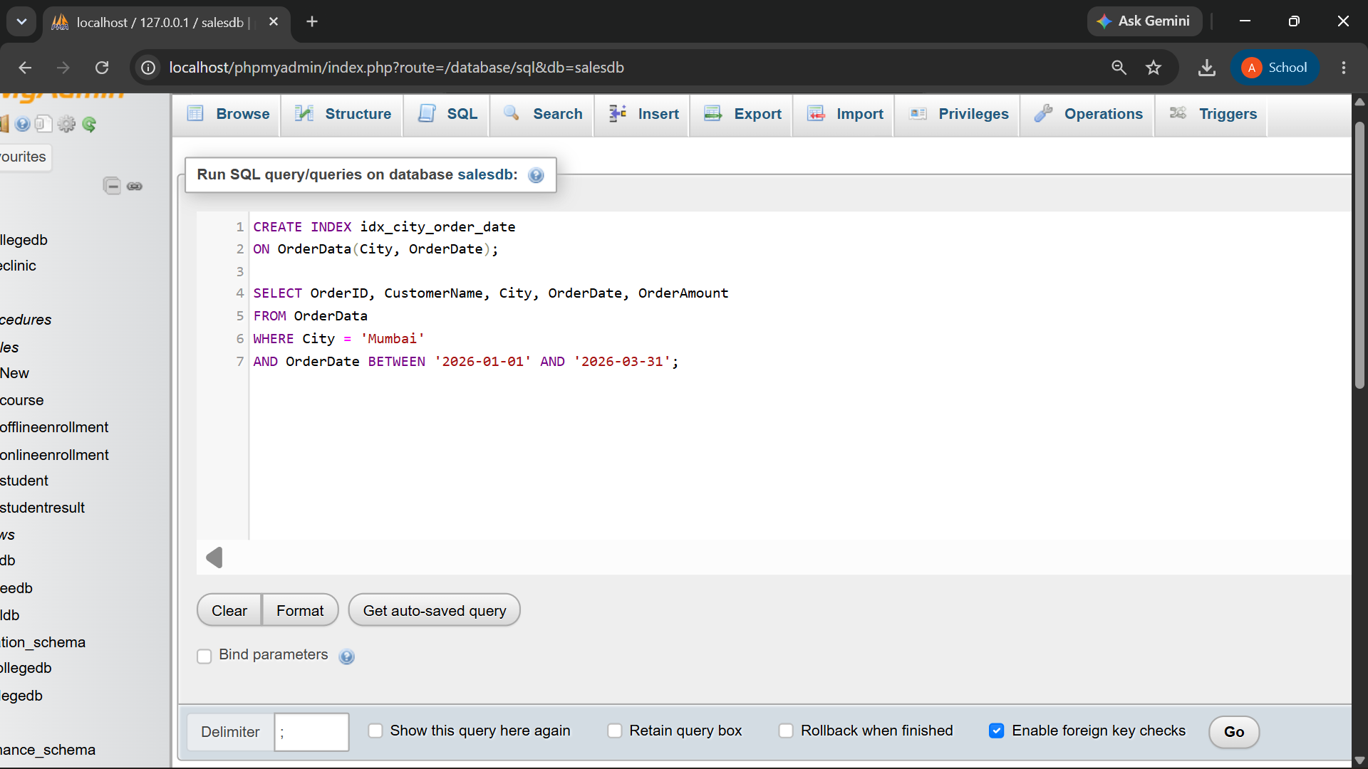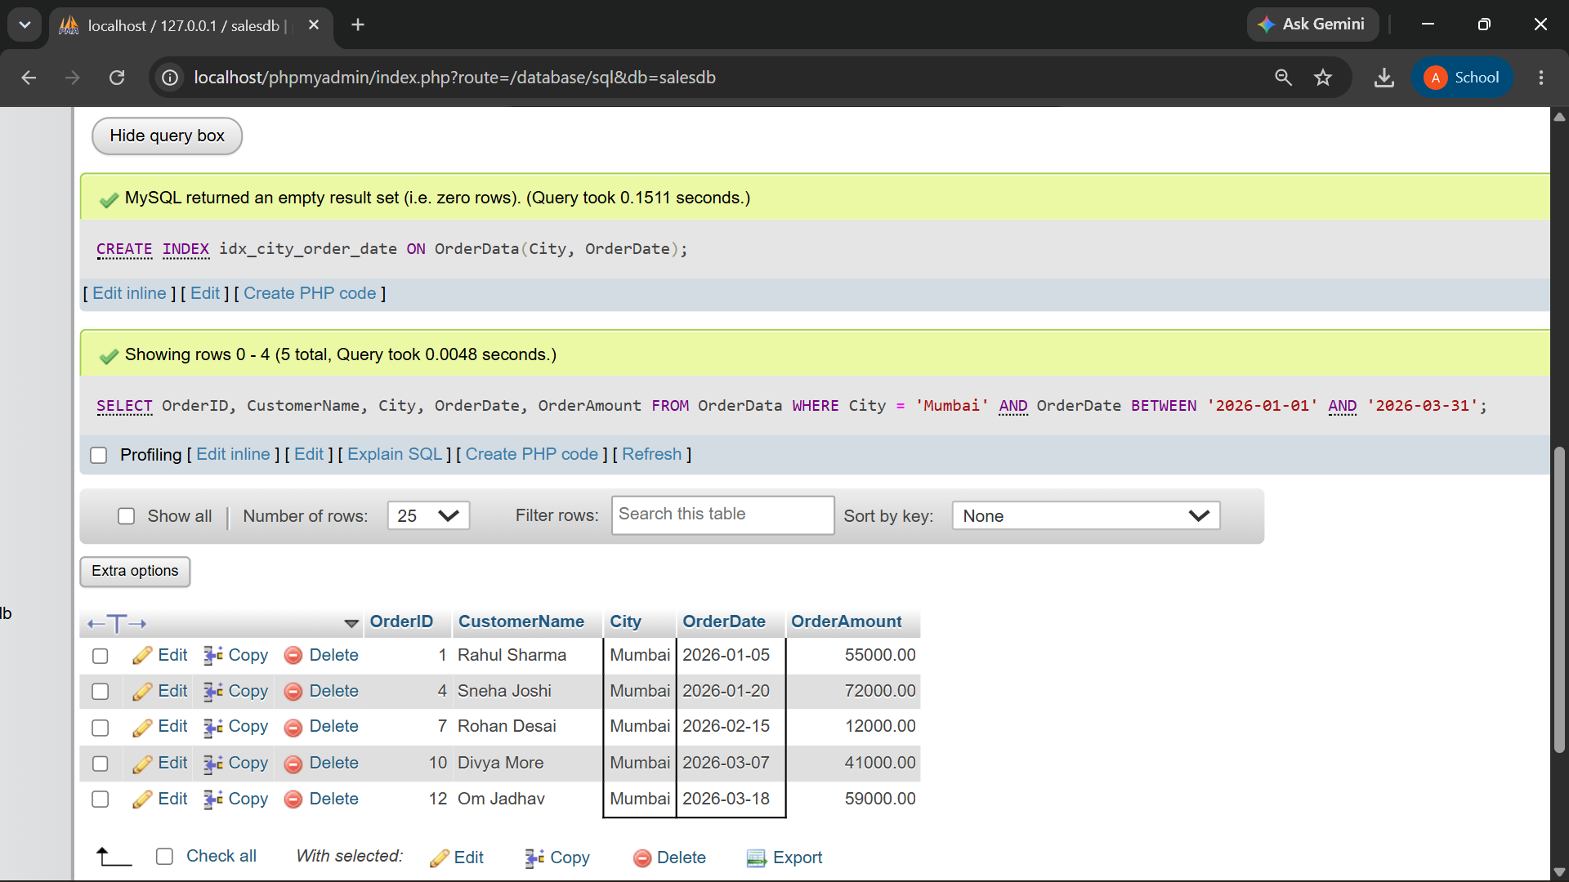

Q4) Write a MySQL EXPLAIN query to analyze the following search:
SELECT *
FROM OrderData
WHERE City = 'Mumbai';
Record and explain the following output columns:
EXPLAIN Column
type
possible_keys
key
rows
Extra

QUERY:

EXPLAIN
SELECT *
FROM OrderData
WHERE City = 'Mumbai';

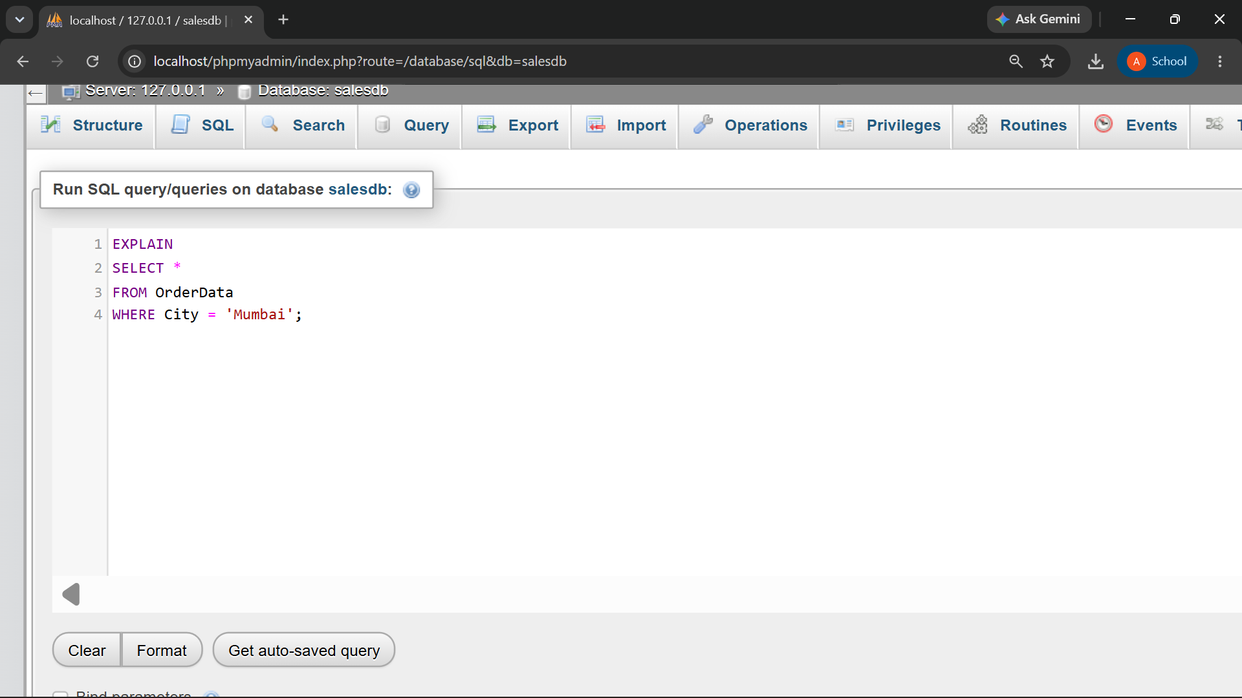

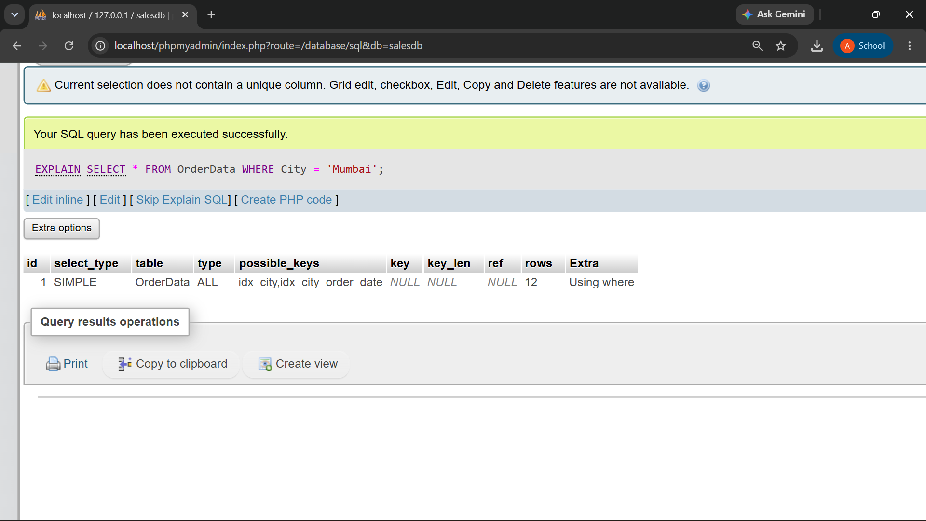

Output Column | Value | Explanation
id | 1 | Unique ID of this execution step in the query plan.
select_type | SIMPLE | The query is a simple SELECT query with no subquery or UNION.
table | OrderData | The table from which MySQL is retrieving the data.
type | ALL | MySQL is performing a full table scan, checking all rows.
possible_keys | idx_city, idx_city_order_date | Indexes that could potentially be used for this query.
key | NULL | No index was actually used; MySQL chose a full table scan.
key_len | NULL | Length of the index key used. It is NULL because no index was used.
ref | NULL | Shows which column/value is compared with the index. NULL because no index was used.
rows | 12 | MySQL estimates that 12 rows need to be examined.
Extra | Using where | MySQL applies the WHERE City = 'Mumbai' condition to filter the rows.

Q5) Compare query performance before and after creating an index on City.
Perform the following steps:
Step | Task
1 | Drop idx_city, if it exists
2 | Run EXPLAIN on the City search
3 | Create idx_city
4 | Run the same EXPLAIN query again
5 | Compare the selected index and estimated rows

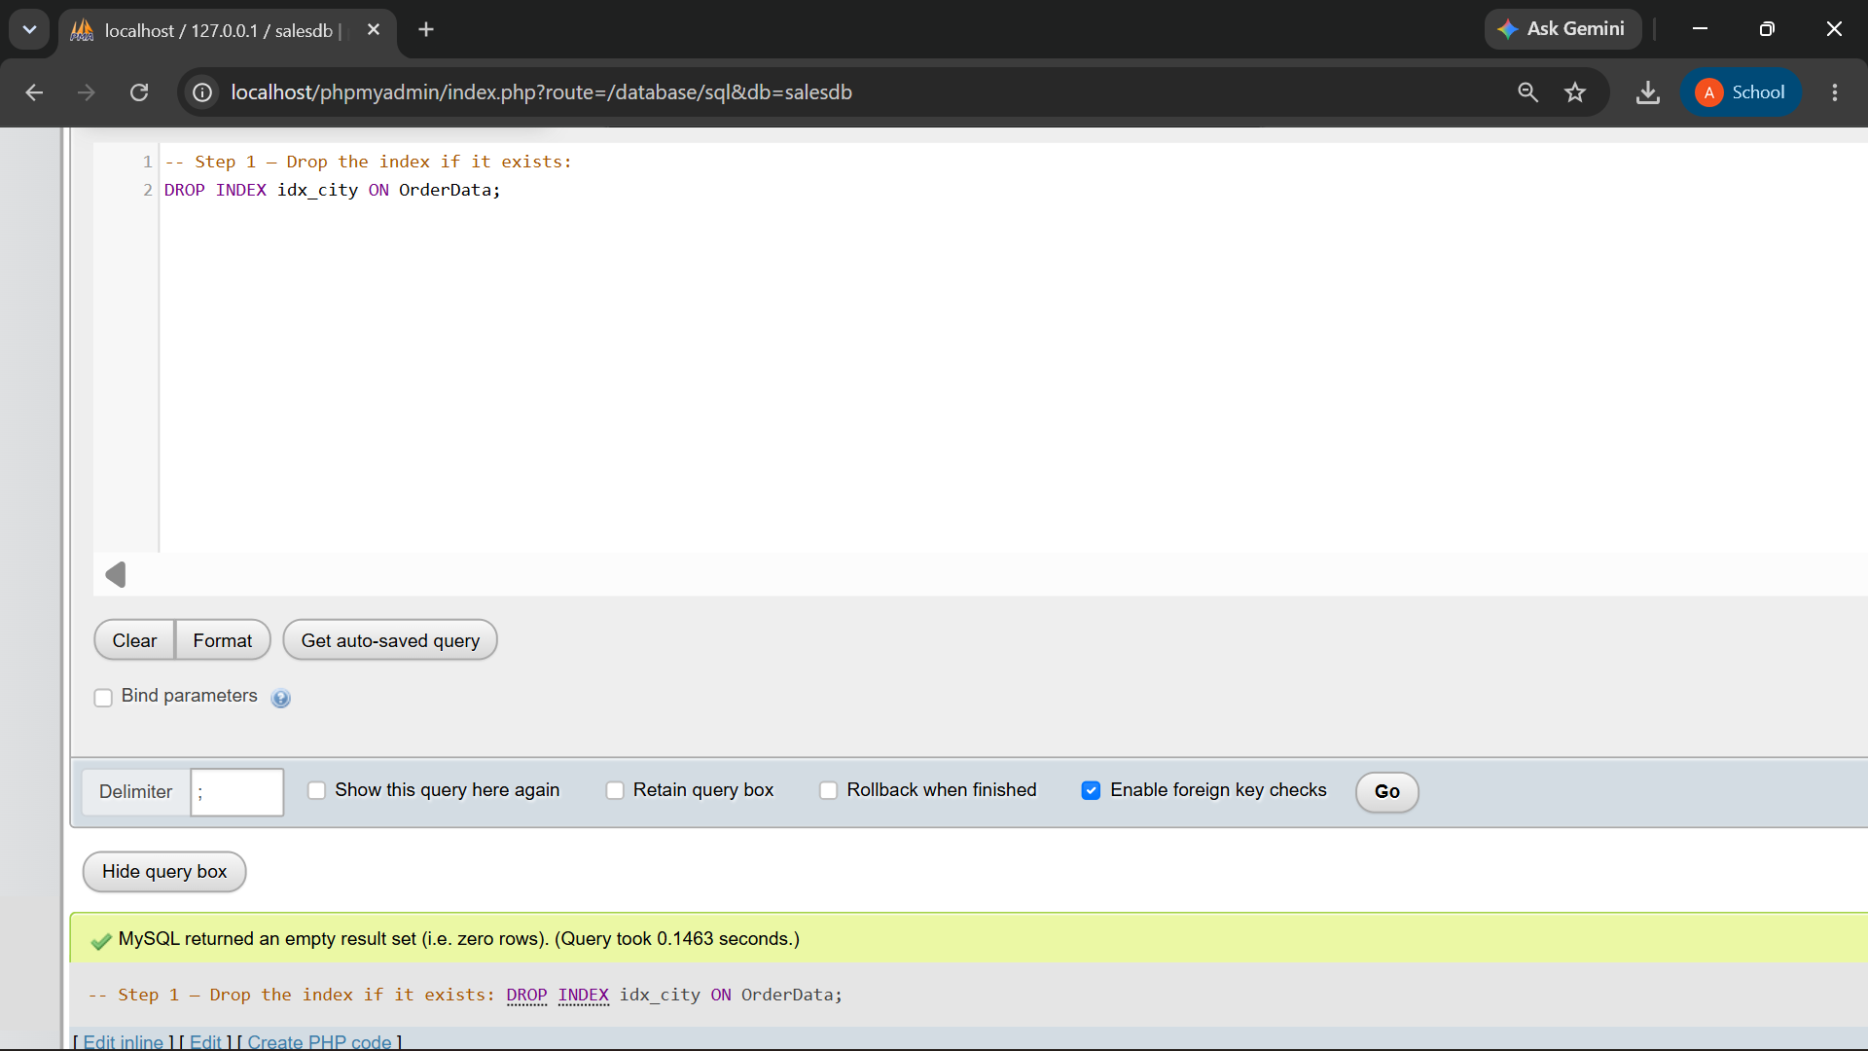

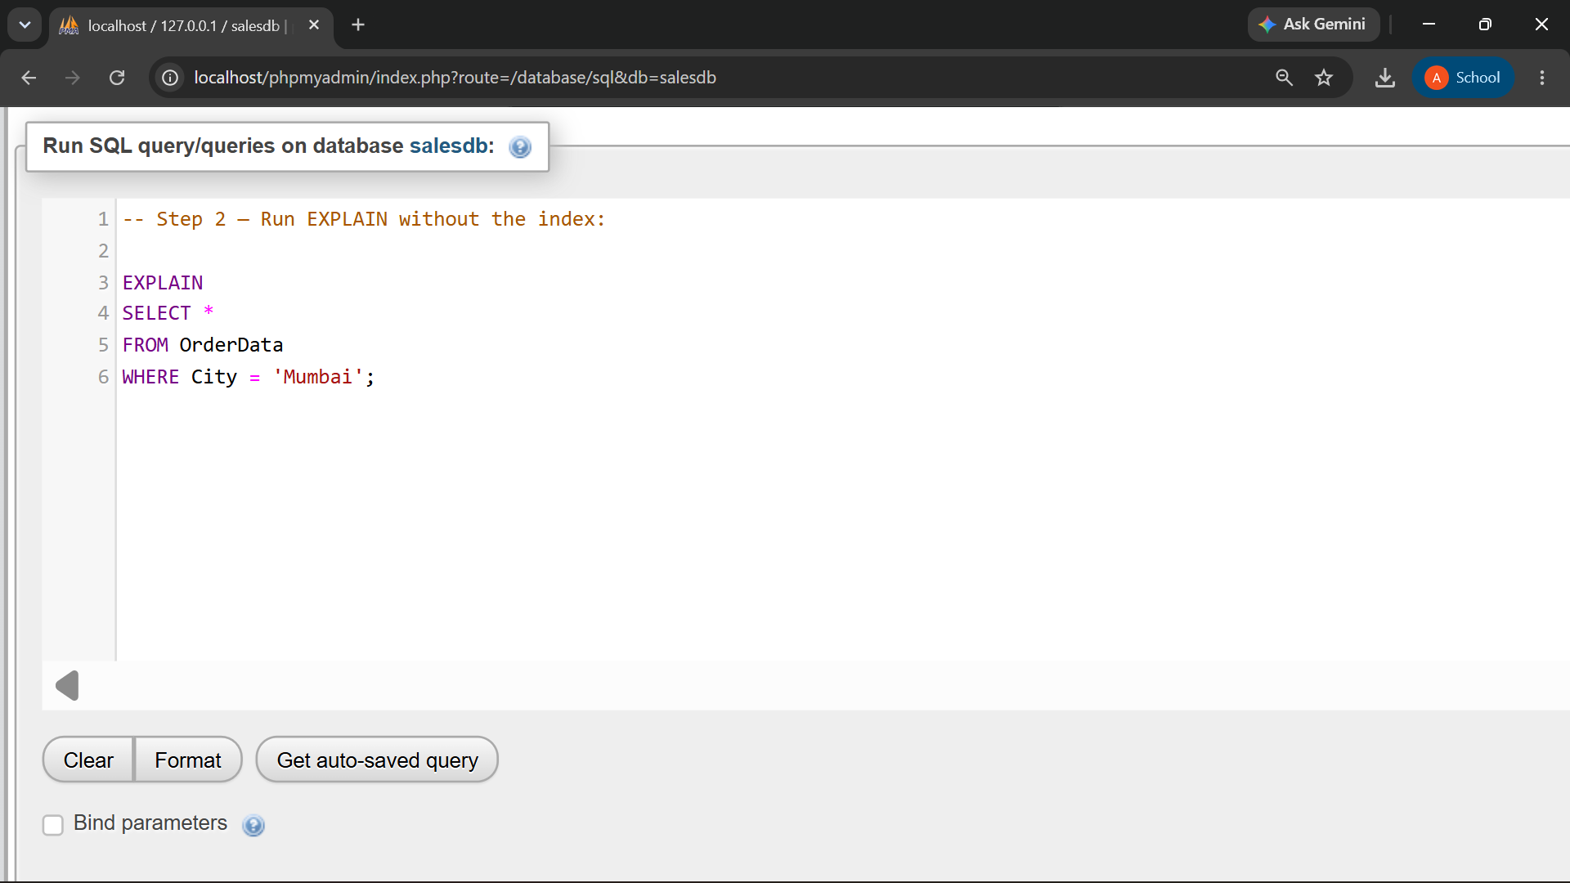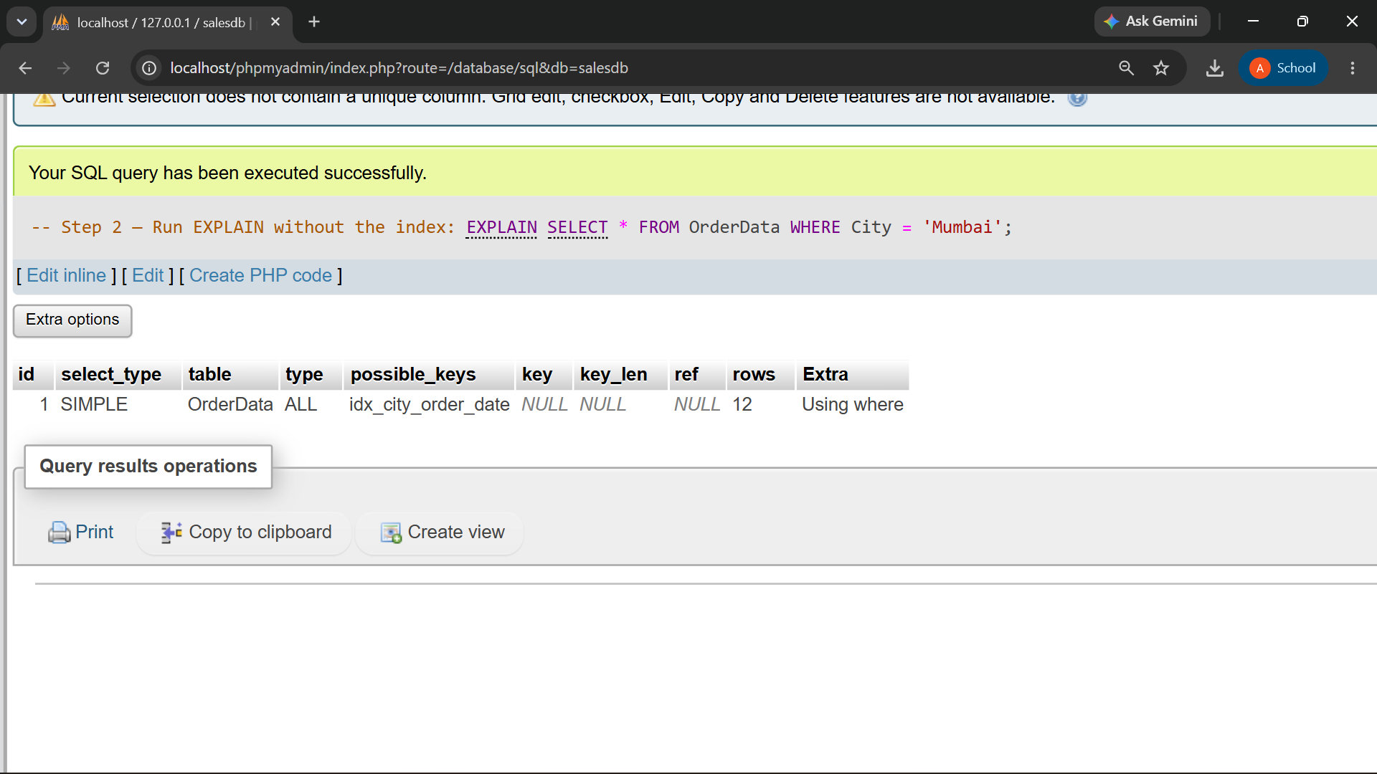

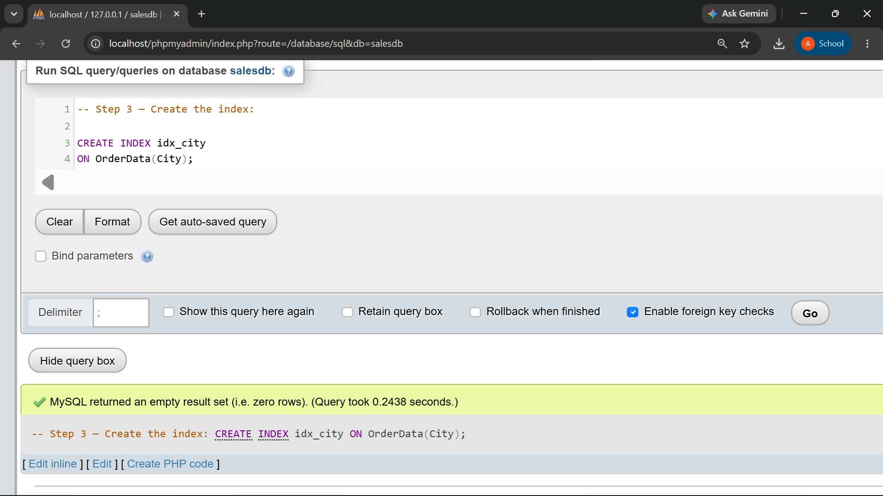

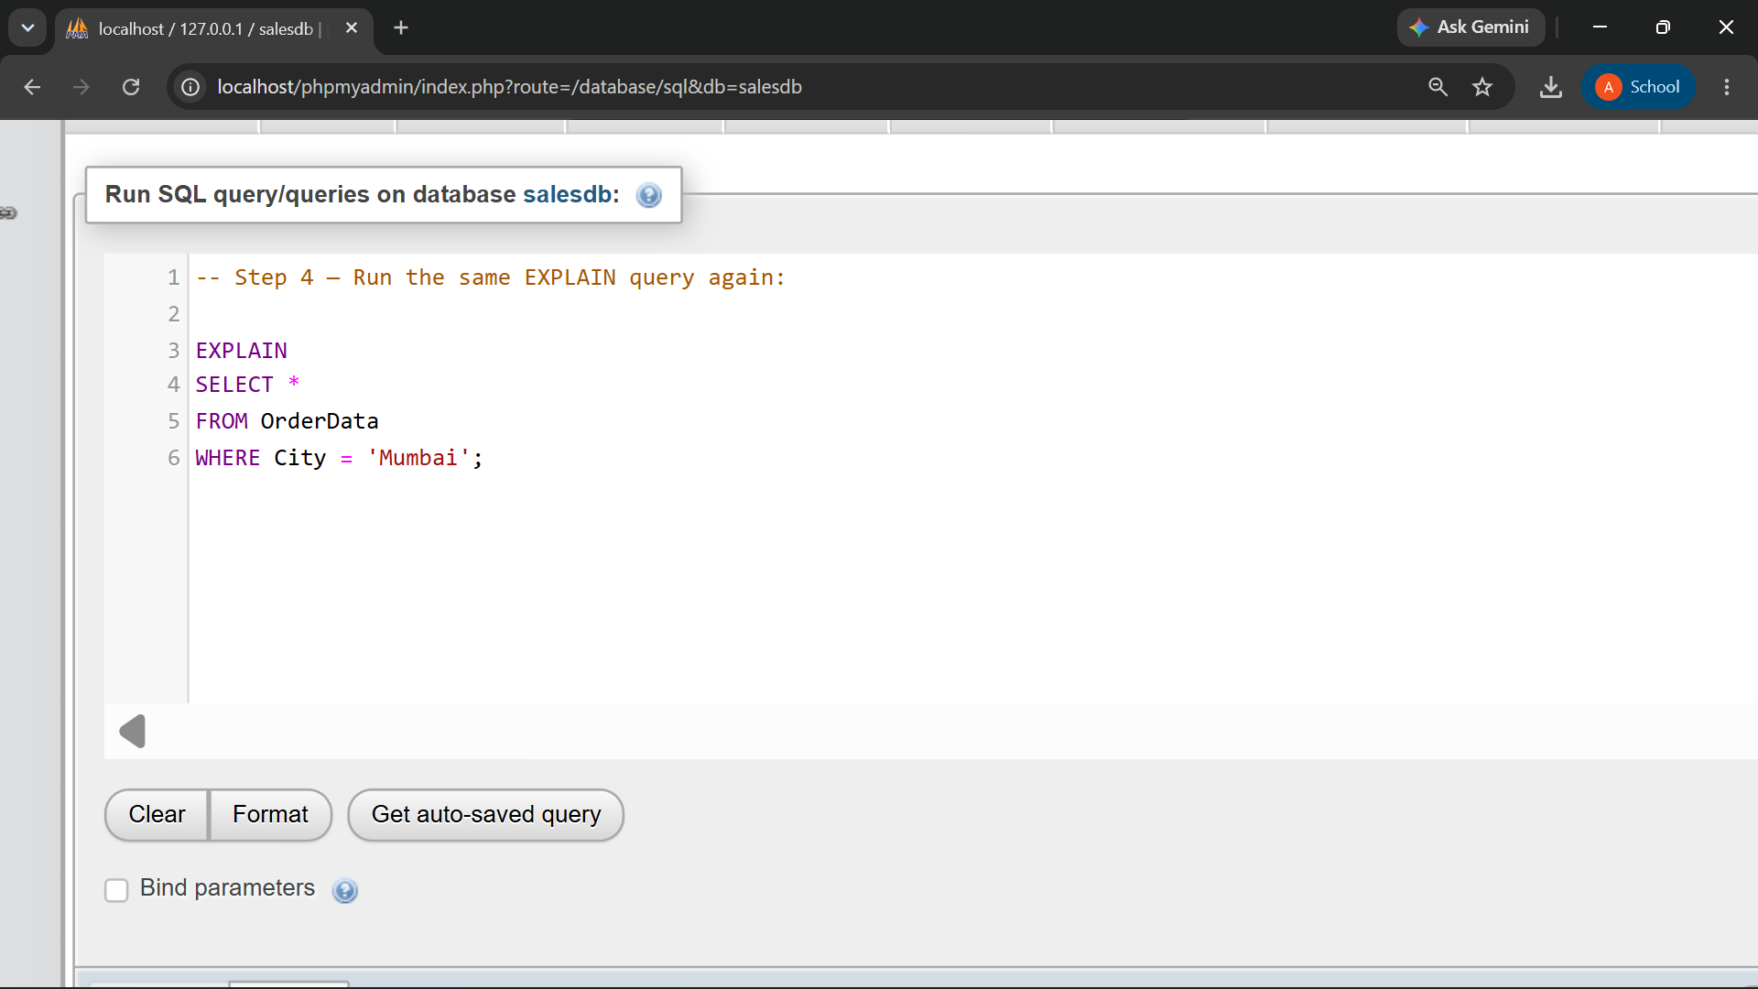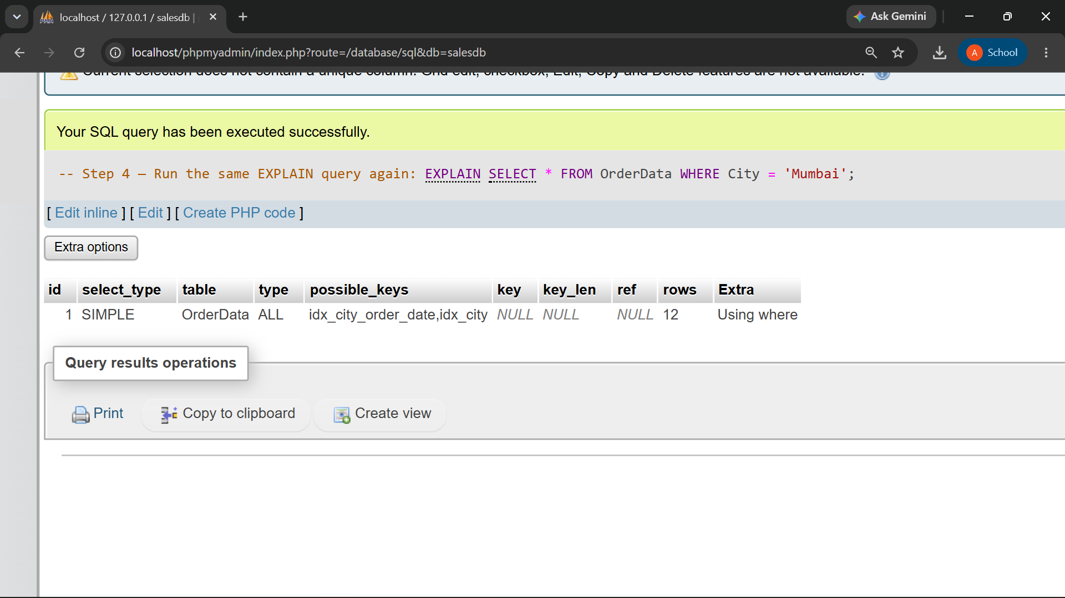

Column | Without/Before Index | After Index | Comparison
type | ALL | ALL | Both perform a full table scan because the table has only 12 rows.
possible_keys | idx_city_order_date | idx_city_order_date, idx_city | After adding the index, MySQL has an additional idx_city index available.
key | NULL | NULL | MySQL did not actually choose an index in either case.
rows | 12 | 12 | MySQL estimates that all 12 rows need to be examined in both cases.
Extra | Using where | Using where | The WHERE City = 'Mumbai' condition is applied to filter the rows.

Conclusion
In this example, the execution plan does not change significantly after adding the index because the table contains only 12 rows. MySQL's optimizer decides that scanning the small table is efficient enough, so type = ALL, key = NULL, and rows = 12 remain the same. With a much larger table, the index may be selected and the type/key values could change.

Q6) Rewrite the following query in a more index-friendly form:

SELECT *
FROM OrderData
WHERE YEAR(OrderDate) = 2026;

The improved query should:

Requirement
Avoid applying a function to OrderDate
Use a start date
Use an end date
Select only OrderID, CustomerName, OrderDate, and OrderAmount
Be analyzed using EXPLAIN
SELECT OrderID, CustomerName, OrderDate, OrderAmount
FROM OrderData
WHERE OrderDate >= '2026-01-01'
AND OrderDate < '2027-01-01';

-- This avoids applying YEAR() to the indexed OrderDate column and uses a direct date range. It can then be analyzed with EXPLAIN:

EXPLAIN
SELECT OrderID, CustomerName, OrderDate, OrderAmount
FROM OrderData
WHERE OrderDate >= '2026-01-01'
AND OrderDate < '2027-01-01';